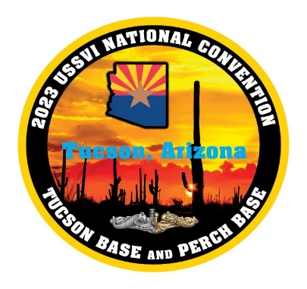
Parking Information

HOTEL: Valet Parking at the hotel is $15 per night
Open Self-Serve Parking at the hotel is no cost
DOWNTOWN: Multiple garages and pay lots are available
Street parking is metered M-F during normal business hours
Covered parking is available at some shopping centers
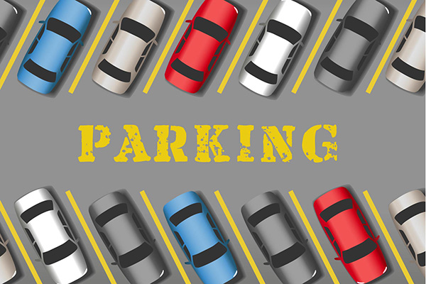

PLEASE NOTE: Parking lot camping (“dry camping”) at the Hilton El Conquistador Hotel is not allowed. Please see the RV Camping Information sheet for many RV & Camping options in our beautiful Tucson area.

