United States Submarine Veterans Inc  Scouting Recognition Program  Presentation Request | 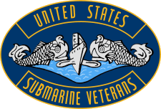

Scout Being Honored

Date of Request:
Name: Age:
Address: City: State: Zip:
Phone Daytime: Evening:
E-mail:
Name as it will appear on certificate:

Presentation Ceremony

Board Review Date:
Date of Presentation: Time:
Location of Court of Honor:
Address: City: State: Zip:
Contact Person
Name:
Address: City: State: Zip:
Phone Daytime: Evening:
E-mail:

Additional Comments

Submit to the Scouting Program Chairman listed below by either postal mail or as an attachment to an E-mail.
David Farran, P.O. Box 825, Waverly, IA 50677-0825
E-mail bream243@q.com

